# 5. Using LCD1602 in Arduino

Difficult Level: 

## A. Introduction

Display LCD1602, or 1602-character type liquid crystal display, is a kind of dot matrix module to show letters, numbers, and characters and so on. It is ideal for displaying text/characters only, hence the name ‘Character LCD’. The display has an LED backlight and can display 32 ASCII characters in two rows with 16 characters on each row. The I2C module converts the signals from the Arduino into commands for the LCD. The LCD has 16x2 cells that can display characters or symbols. Each cell consists of 5x8 dots that can be turned on or off by applying voltage. The LCD can display different characters or symbols by turning on or off different combinations of dots.

An I2C LCD1602 consists of a normal LCD1602 and an I2C module that is attached to the back of the LCD. The I2C module is a chip that can expand the I/O ports of the Arduino using the I2C protocol. The I2C protocol is a serial communication protocol that uses two wires: SDA (serial data) and SCL (serial clock). The I2C protocol allows multiple devices to communicate with each other using only two wires and unique addresses.

## B. Display the temperature and humidity in the LCD1602

### What you need

* Arduino IDE software
* 1 x Arduino UNO R4 Wi-Fi
* 1 x USB 2.0 cable type A/B
* 1 x I2C LCD 1602
* 1 x Temperature and humidity sensor Module
* 3 x Male-Male Jumper wires
* 4 x Female-Male Jumper wires
* 1 x 52Pi Bread Board

### How to wiring circuit diagram?

|  |  |
| --- | --- |
| Arduino UNO R4 WIFI | Temperature and humidity sensor |
| 3.3V | VCC |
| GND | GND |
| Pin 2 | DATA |

|  |  |
| --- | --- |
| Arduino UNO R4 WIFI | I2C LCD 1602 |
| 5V | VCC |
| GND | GND |
| A4 | SDA |
| A5 | SCL |

You can look at the circuit connection diagram below to connect our own devices.

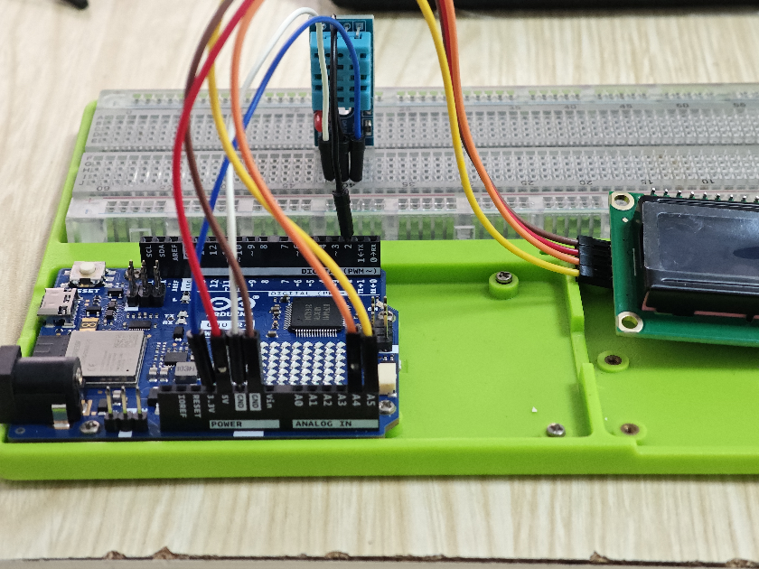

Then connect the computer with the Arduino UNO R4 WIFI. Open the Arduino IDE, copy and paste the code.

**#include <LiquidCrystal_I2C.h>**

**#include "DHT.h"**

**#define DHT11_PIN 2  // Define the pin used to connect the sensor**

**#define DHTTYPE DHT11  // Define the type of the sensor**

**LiquidCrystal_I2C lcd(0x27, 16, 2); // I2C address 0x27, 16 column and 2 rows**

**DHT dht11(DHT11_PIN, DHT11);  // Create a DHT object**

**void setup()**

**{**

**dht11.begin();     // initialize the sensor**

**lcd.init();        // initialize the lcd**

**lcd.clear();       // clear the LCD display**

**lcd.backlight();   // Make sure backlight is on**

**}**

**void loop()**

**{**

**// wait a few seconds between measurements.**

**delay(2000);**

**// read humidity**

**float humi  = dht11.readHumidity();**

**// read temperature as Celsius**

**float tempC = dht11.readTemperature();**

**lcd.clear();**

**// check if any reads failed**

**if (isnan(humi) || isnan(tempC)) {**

**lcd.setCursor(0, 0);   //put "Failed" in LCD1602 (0,0)**

**lcd.print("Failed");**

**} else {**

**lcd.setCursor(0, 0);  // start to print at the first row**

**lcd.print("Temp: ");**

**lcd.print(tempC);     // print the temperature**

**lcd.print((char)223); // print ° character**

**lcd.print("C");**

**lcd.setCursor(0, 1);  // start to print at the second row**

**lcd.print("Humi: ");**

**lcd.print(humi);      // print the humidity**

**lcd.print("%");**

**}**

**}**

Library Inclusion and LCD Initialization: The LiquidCrystal I2C library is included to provide functions and methods for LCD interfacing. Following that, an LCD object is created using the LiquidCrystal_I2C class, specifying the I2C address, number of columns, and number of rows.

Inclusion of necessary libraries. This part of the code includes the DHT sensor library and defines the pin number and sensor type used in this project. Creation of DHT object.

**#include <LiquidCrystal_I2C.h>**

**#include "DHT.h"**

**#define DHT11_PIN 2  // Define the pin used to connect the sensor**

**#define DHTTYPE DHT11  // Define the type of the sensor**

**LiquidCrystal_I2C lcd(0x27, 16, 2); // I2C address 0x27, 16 column and 2 rows**

**DHT dht11(DHT11_PIN, DHT11);  // Create a DHT object**

Then we initialize in setup (), such as LCD initialization, DHT initialization.

**dht11.begin();     // initialize the sensor**

**lcd.init();        // initialize the lcd**

**lcd.clear();       // clear the LCD display**

**lcd.backlight();   // Make sure backlight is on**

The loop () function runs continuously after the setup function. Here, we read the humidity and temperature values, and print these values to the LCD1602.

**Loop(){**

**……… //print values to the LCD**

**}**

If you do not need to output the temperature and humidity values, you can use this method to change what you need to output.

**lcd.setCursor(0, 1);  // start to print at the second row**

**lcd.print("Hello world"); // what you want to display and you need clear other display first so that you can get what you want**

Then we can upload our program into the Arduino UNO R4 WIFI. After upload successful, we can see “temp” and “humi” in the LCD1602.

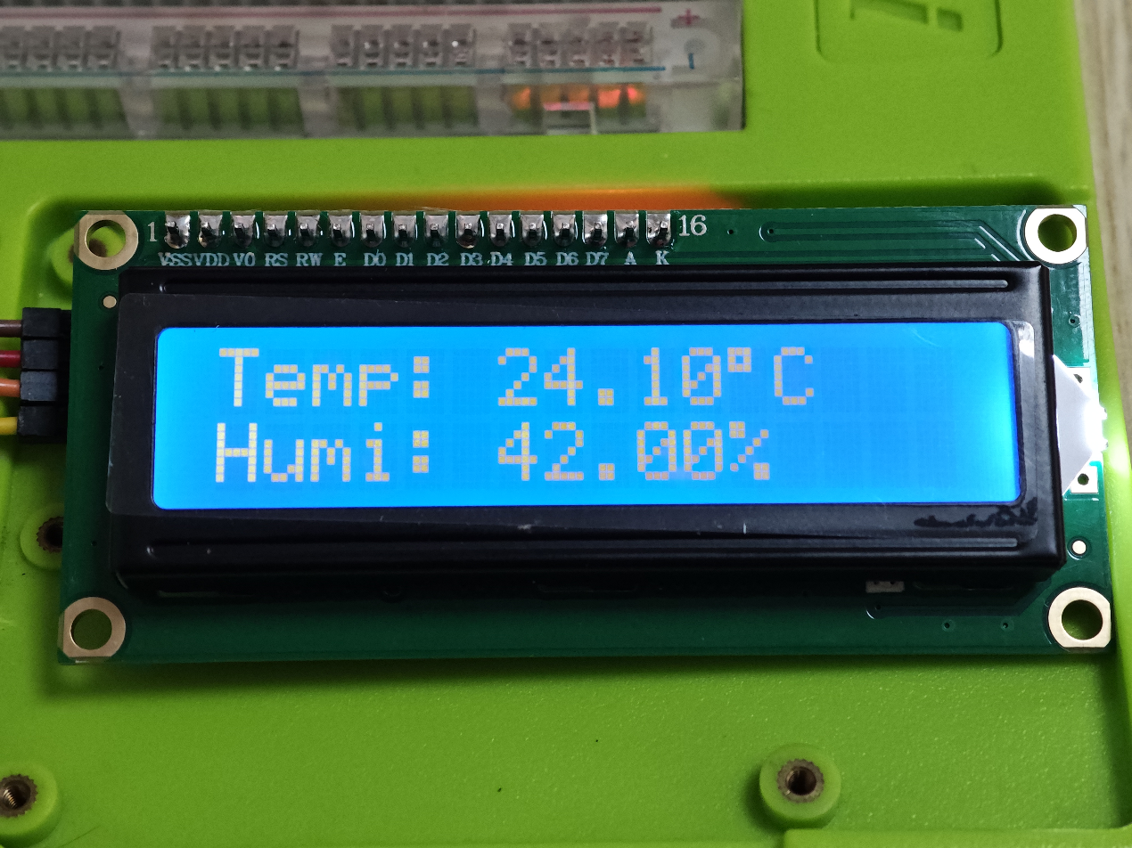

## C. Extension

The user can toggle the content displayed on LCD1602 with a button. Based on the previous project, you need add a Press button and 2 x male to male jumper wires.

### How to wiring circuit diagram?

|  |  |
| --- | --- |
| Arduino UNO R4 WIFI | Temperature and humidity sensor |
| 3.3V | VCC |
| GND | GND |
| Pin 2 | DATA |

|  |  |
| --- | --- |
| Arduino UNO R4 WIFI | I2C LCD 1602 |
| 5V | VCC |
| GND | GND |
| A4 | SDA |
| A5 | SCL |

|  |  |
| --- | --- |
| Arduino UNO R4 WIFI | Button |
| Pin 7 | VCC |
| GND | GND |

You can look at the circuit connection diagram below to connect our own devices.

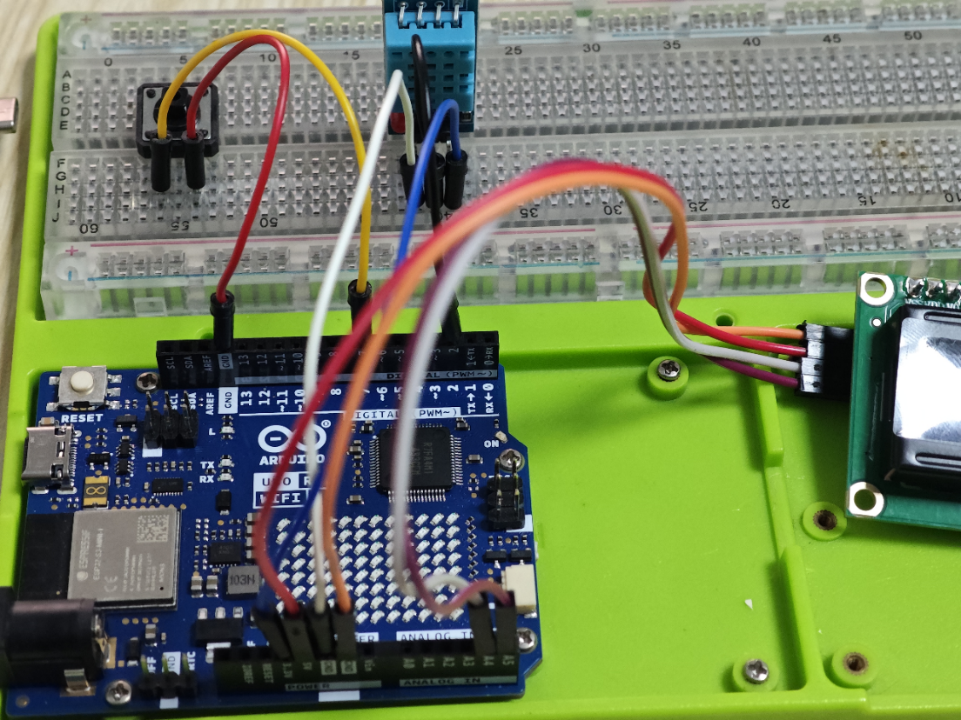

Then connect the computer with the Arduino UNO R4 WIFI. Open the Arduino IDE, copy and paste the code.

**#include <LiquidCrystal_I2C.h>**

**#include "DHT.h"**

**#define DHT11_PIN 2        // Define the pin used to connect the sensor**

**#define DHTTYPE DHT11      // Define the type of the sensor**

**const int BUTTON_PIN = 7;  // the number of the pushbutton pin**

**LiquidCrystal_I2C lcd(0x27, 16, 2);  // I2C address 0x27, 16 column and 2 rows**

**DHT dht11(DHT11_PIN, DHT11);         // Create a DHT object**

**int lastButtonState = 0;     // the previous state of button**

**int currentButtonState = 0;  // the current state of button**

**int state = 0;**

**void setup() {**

**dht11.begin();                      // initialize the sensor**

**pinMode(BUTTON_PIN, INPUT_PULLUP);  // set arduino pin to input pull-up mode**

**lcd.init();       // initialize the lcd**

**lcd.clear();      // clear the LCD display**

**lcd.backlight();  // Make sure backlight is on**

**currentButtonState = digitalRead(BUTTON_PIN);**

**}**

**void loop() {**

**delay(500);                 //Refresh the temperature and humidity data every 0.5s**

**lastButtonState = currentButtonState;          // save the last state**

**currentButtonState = digitalRead(BUTTON_PIN);  // read new state**

**// read humidity**

**float humi = dht11.readHumidity();**

**// read temperature as Celsius**

**float tempC = dht11.readTemperature();**

**// read temperature as Fahrenheit**

**float tempF = dht11.readTemperature(true);**

**if (isnan(humi) || isnan(tempC) || isnan(tempF)) {**

**lcd.setCursor(0, 0);  //put "Failed" in LCD1602 (0,0)**

**lcd.print("Failed");**

**}**

**if (state == 0) {**

**display_tempC(tempC, humi);    //display temperature and humidity**

**} else {**

**display_tempF(tempF, humi);   //display Fahrenheit temperature and humidity**

**}**

**if (currentButtonState == 0 && lastButtonState == 1) {     //when the button is pushed**

**state = !state;                       //change state and display another temperature**

**}**

**}**

**void display_tempF(float temp, float humi) {**

**lcd.clear();          //clear the last display, and update the LCDdisplay**

**lcd.setCursor(0, 0);  // start to print at the first row**

**lcd.print("Fahr: ");**

**lcd.print(temp);       // print the Fahrenheit temperature °F**

**lcd.print((char)223);  // print ° character**

**lcd.print("F");**

**lcd.setCursor(0, 1);  // start to print at the second row**

**lcd.print("Humi: ");**

**lcd.print(humi);  // print the humidity**

**lcd.print("%");**

**}**

**void display_tempC(float temp, float humi) {**

**lcd.clear();           //clear the last display, and update the LCDdisplay**

**lcd.setCursor(0, 0);  // start to print at the first row**

**lcd.print("Temp: ");**

**lcd.print(temp);       // print the temperature °C**

**lcd.print((char)223);  // print ° character**

**lcd.print("C");**

**lcd.setCursor(0, 1);  // start to print at the second row**

**lcd.print("Humi: ");**

**lcd.print(humi);  // print the humidity**

**lcd.print("%");**

**}**

**Note:** you need to remember to install the library.

In the loop () function, First I set a delay to make sure it refreshes every 500ms. Then read the status of the button, read the data of the temperature and humidity sensor. A status bit is set to toggle the output of the screen, and when the button is pressed next, the status bit changes.

**if (state == 0) {**

**display_tempC(tempC, humi);    //display temperature and humidity**

**} else {**

**display_tempF(tempF, humi);   //display Fahrenheit temperature and humidity**

**}**

Then, upload the code into your Arduino UNO R4 WIFI. After you finished upload, you can push the button to change the temperature from Fahrenheit temperature and humidity to

Celsius temperature and humidity. (Sometimes you need to keep press several seconds then release it, because we need to debounce for the button)

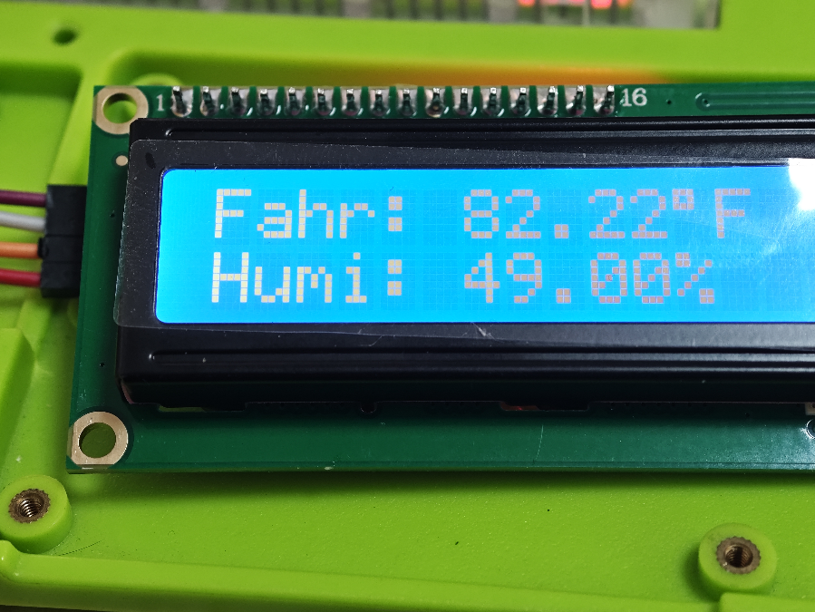

Click the button.

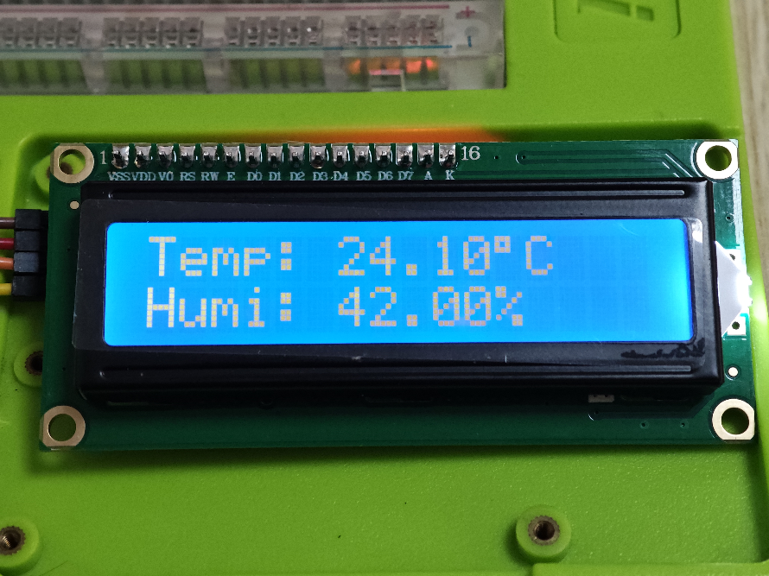

**Congratulations！**



You have already got this new skills!!! and let’s get into next chapter!